CONSIDERATIONS FOR COVID VACCINATION IN MULTIVERSE

The situation here is more complex, but the conclusions are clear. Refer to Technical Report #006 for a detailed description of the Multiverse.

A brief summary follows. There are 9 Universes in the Multiverse, and each has its own intrinsic mingleFactor. For simplicity, the following trials are taken OutOfTheBox, using the data files Population.csv and VL5.csv (which gives 5 initial transmitters, all school children).

The Universes, the 100 persons, and their population categories, including their family structures, are briefly described below.

There are 9 Universes in this Trial called U0 to U8. The names assigned to them are:

U0 Classroom 1

U1 Project/Lab Room

U2 Lunchroom

U3 Playground

U4 Classroom 2

U5 Teacher’s Lounge

U6 LTC (Long Term Care)

U7 High Mingle site (Bar, reception, party)

U8 HOME

HOME is a unique Universe, in that transmissions among agents who are in the HOME universe only take place between members of the same family.

The population structures are as follows:

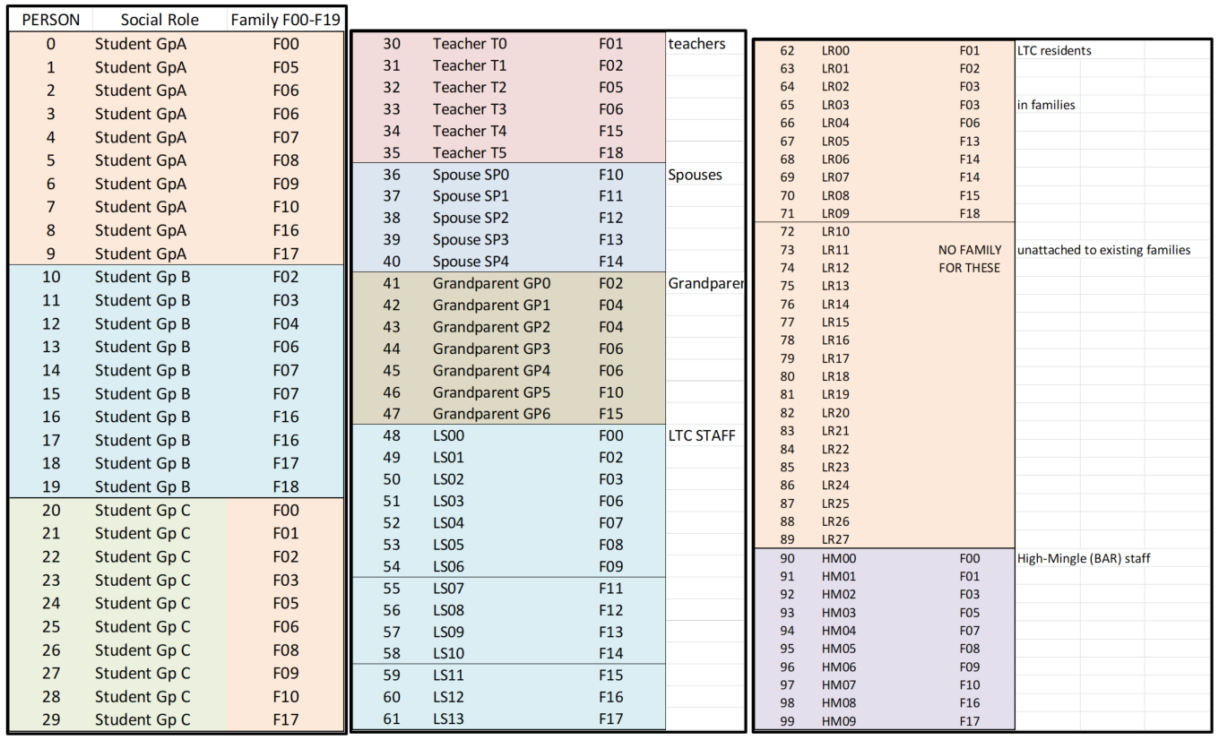

and the 18 families are constituted as follows:

There are 9 Universes in this Trial called U0 to U8. The names assigned to them are:

U0 Classroom 1

U1 Project/Lab Room

U2 Lunchroom

U3 Playground

U4 Classroom 2

U5 Teacher’s Lounge

U6 LTC (Long Term Care)

U7 High Mingle site (Bar, reception, party)

U8 HOME

HOME is a unique Universe, in that transmissions among agents who are in the HOME universe only take place between members of the same family.

The schedule of movements of populations between Universes are as follows. This schedule is repeated daily although CovidSIMVL has the ability to describe different schedules each day of the week.



The Vaccination Trials

Our aim is to compare the effect of vaccinations on a canonical population of 100 as constituted above, to observe the downstream effects of vaccination, compared to NoVax, at specific times. In addition, we follow the epidemic to termination, which is either by consuming all susceptibles, or by self-extinction, at which time there are no infectives left.

We start each trial with 5 infected students, agents 10-14, with a baseline Hazard Radius of 5, and a mingleFactor of 10 showing as default. Note that the Population.csv file assigns each agent a mingleFactor on initiation, which may change as they take on different roles in different Universes. We do not modify these, but run everything OutOfTheBox, except for the schedule of vaccinations.

The Schedule of Vaccination Trials

We will report on (all Vax at 100% less 1/5 for NoVaxers and 95% efficacy). The schedule is for the second injection, and we assume that the first has been given 23 days prior.

NoVax

LTC at D08 and D016 (day zero hour 8, and day 0 H16)

Home at D0.6 (day zero hour 6), D0.12, D0.18, D0.24

Bar at D0.10,D0.12,D0.14,D0.16,D0.18.D0.20,D0.24

School: U2 (Playground) at D0.10, U3 (Lunchroom) at D0.11, U1 at D0.11

We take the count of remaining susceptibles in the Multiverse (all 100) at times:

D1.20, D2.20, D3.20, D4.20, then D8.20, D12.20, D16.20 etc till termination

At this point, we record R0, which describes at the broadest level, the intensity of the overall epidemic across all the Universes for that trial.

The Analysis

We compare in detail below the NoVax and the LTC Vax trials, and then summarize the other trials.

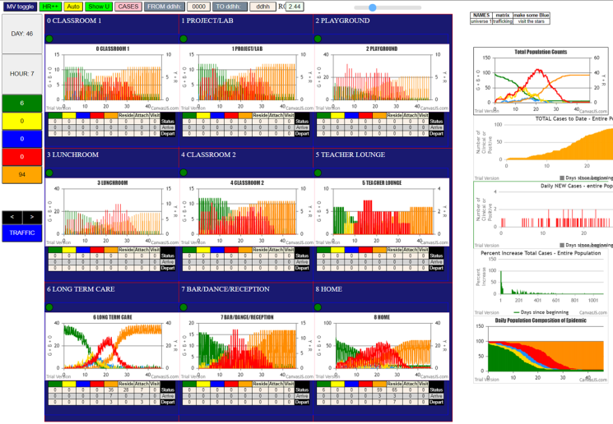



Salient observations:

1. R0 is 2.44 a rapid epidemic, which terminates with 6 left, ag Day 46 H6.
2. The SEIR graph on top right shows max cases (reds) at 40 on day 20
3. The Universe charts show the status of agents in them, not whether they were infected there.
4. The table above shows in the inner column the susceptibles overall, and the number infected at that time is calculated by taking 100, less 5 initial cases.

Comparing this NoVax to LTC Vaccination, we have for LTC-Vax 1 and Vax 2 both at 100% for times D0.8, and D0.16 (8am and 4pm on Day 0) integrated into the same table:



Notably, 38 persons are removed from the pool of susceptibles, and the two trials are similar so far.

In LTC-1, 13 susceptibles remain at the end, and 9 in LTC-2.

For NoVax, the same number was 6.

At termination, in LTC-1 there were 44 new infections, and 49 for LTC-2, compared to 89 for NoVax. Of course, the vaccinations removed 38 and 39 from the susceptible pool.

If we took a comparable time say D16.20, NoVax had 70 new cases, while LTC-1 had 31 and LTC-2 had 23. If we add back the 38 and 37 immune cases to LTC-1 and LTC-2 respectively, we get 69 and 60. So the infection of the rest proceeded much the same. However, noVax has larger case numbers, and also finished earlier (last infection at gen580, half that of the others), so we have a slower epidemic, with fewer cases.

It might appear that LTC-2 had a gain of 10 cases at D16,20, but at the end, LTC-2 had 49 new cases, which added to the 37 immune agents, ends up with 86 cases, not far from the 89 cases for NoVax. The LTC-1 trial had 44 cases + 38 immunes, which at 82 is also close to the 89 for NoVax.

It appears at this point that while the vaccinated are protected, the remainder get no secondary protection from the immunity of the others. At this point, we have not yet tested giving vaccine not at D0 but perhaps at D8, when there are more simultaneous transmitters. This will be discussed later.

One further analysis we can do at this point is to inquire as to what and where the epidemic takes place after the LTC vax has been given. We can derive these numbers from the console.logs.

This table shows that for noVax, of the first 20 transmissions, 50% of them took place in U8 (Home). When all the transmissions are considered together, the LTC (Universe 6) is by far the largest at 46, with Home following at 15. This is consistent for the two trials of noVax.

When LTC-1 and LTC-2 are considered, there having been 38 and 37 immunes removed from the susceptibles pool by immunizing in Universe 6 (LTC), we end up with Universe 8 (Home) being the main arena for transmissions at 13 and 18 respectively. This pattern also holds for the first 20 transmissions in both LTC cases.

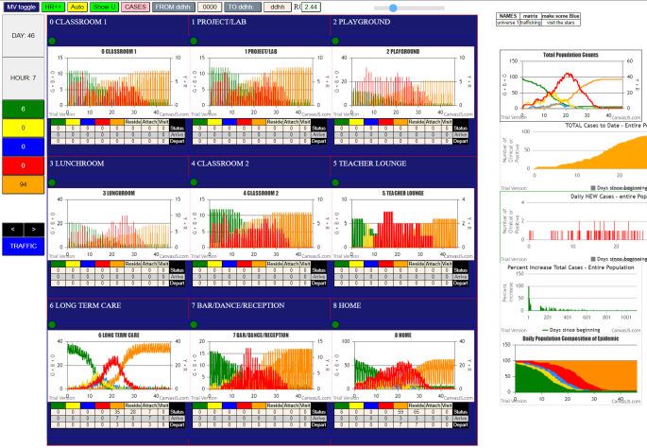Comparing the results in the Multiverse Charts for noVax1 and LTC-1, we have:

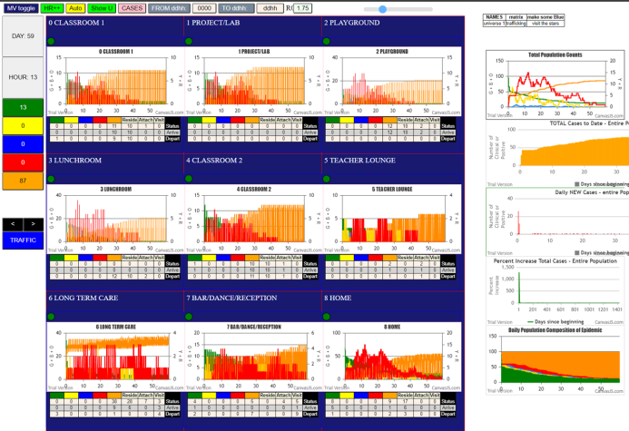On the left is noVax, and on the right is LTC-1. At this point of the discussion, which is general, we can state that schools are not affected much, while in the last 3 Universes (LTC, Bar and Home), the peak case values are lower and occur earlier than for the noVax case.

The corresponding results for the other trials, of vaccinating in the school rooms, and vaccination taking place in the bars and at HOME (6am, 12pm, 4pm, and 2400hrs) are shown below. We will not produce the charts, nor the detailed analysis, but data that focuses on the number of new cases following immunization numbers.

It appears that Home yields the highest number of immunes, but that is tantamount to a random infection of the entire population, rather than there being a single physical location called “HOME”.



The observation so far is that vaccination confers immunity, but the rest of the susceptibles will be subject to becoming cases.

Two questions remain:

1. Will a later vaccination schedule make things worse
2. Will vaccinating Home + LTC produce added benefits?

We turn to delaying the vaccination schedule for LTC to D8.0. The same parameters for the trial, and at D8.8 we turned to U6 and applied 100% vaccination and again at D8.16 for a total of 26 persons made immune. We then continued till termination at D48.3, with an R0 of 2.00, leaving 12 susceptibles.

A comparison against noVax and LTC-1 and LTC-2 shows:

The downside of delaying vaccination is that only 26 are immunized instead of 38 and 37 in the LTC trials. The best portrayal of benefit is in D24.20, in which the noVax cases have climbed to 88, while the Delayed-LTC has 51 new cases, while the LTC-1 and LTC-2 have 34 and 35 new cases respectively.

The 51 new cases + 26 immunized account for 77 cases, while the noVax has 88 cases. This is a net benefit of 11 cases incurred in addition to the immunized patients, at this moment in time.

The respective net gains for LTC-1 and LTC-2 are 88 – (34+38) and 88 – (35+37) or 88 – (72) = 16 cases.

The loss for delaying the vaccination is therefore (16-11)/16 = 5/16 or 31%. This is reasonably significant.

The other question is whether vaccinating LTC and HOME, the two major areas in which transmissions occur, will improve matters significantly. We will try at D0, with 100% and 50% respectively.

We have added the 50% at D0.8 and D0.16 in both U6 (LTC) and U8 (HOME). Those are the two columns to the left. The 100% LTC + HOME was vaccinated at D0.8 only, and produced 67 agents to be immunized.

The results are interesting, as the 100% aggressive vaccination produced 67 immunized, but at D24.20, where the noVax had 88 cases, the 100% D8 LTC+H had 19 new cases, which when added to the 67 immunized, yields a total of 86, which is only a net improvement of 2.



On the other hand, the 50% D0.8 and D0.16 vaccinations at 50% each only yielded 44 immunes removed from the pool of susceptibles, but at D24.20 the number of new cases is 30. When this is added to the 44 immunes, we get 74, which compared to the 88 cases for noVax, is a net benefit of 14 cases. Plus, it leaves 15 susceptibles untouched at termination of D45.0, which is

This slower vaccination schedule in the complex multiverse is somewhat puzzling. We will examine the D24.20 row for all the trials performed to date:



It would appear that at any point in the epidemic, the sum of the number of susceptibles remaining plus the number immunized is an estimate of the net benefit when compare to the noVax number at that point. The correlation of net benefit of the vaccination schedule to the number of susceptibles remaining at the extinction of the epidemic also appears strong.

However, this strange result does not tell us what kind of schedule to use. It nevertheless, in this complex situation, raise the question of whether brute force (as early and as hard as possible) misses out on some intangible benefit when compared to noVax course of the epidemic.

It must not be forgotten that the primary tenet holds: the more agents are vaccinated as soon as possible, the fewer the actual number of new sick cases. An examination to the table above confirms this fundamental finding.

The first two columns on the left, for example compares L+H at 50% vaccination at D0.8 and D0.16 vs 100% vaccination at D0.8. The first approach produced 44 immunized persons, the second 67. The result of truest significance is that with the 67 immunized, only 20 new cases occur, whereas the slower strategy produced 36 new cases.

This intuitive result that the higher the number of vaccinations, the fewer the new cases, is the best observation from these model studies. The notion that compared to no vaccinations, a slower schedule appears to proceed at a slower rate of infection does not overcome the absolute numbers being more important than the apparent rate.

In the final analysis, it is the number of new cases that truly matter. The comparison on delayed vaccination of LTC at D8 versus at D0, showed that it only produced 26 vaccinations vs 38 and 37 for the two LTC trials. The new case count for LTC-D8 was 57, worse than the 44 and 49 case counts for the tow LTC vaccinations done at D0.

DISCUSSION

The Universes that had the most transmissions with no vaccinations were U8 (Home) and U6 (LTC). When one or the other was vaccinated first, the other became the dominant Universe of transmission. When both were vaccinated together the results were superior to any other Universe, except aggressive vaccination of the HOME Universe. This was of course practically the same as mass random inoculation.

When considering the degree of vaccination, and delays, the modelling shows quantitatively that there are increases in new cases if less than full effort and the earliest possible strategies were not adopted.